5. Program Effectiveness – Outcomes Assessment
Undergraduate
Civil Engineering BS Program Educational Outcomes
The educational objectives of our Civil Engineering Program are that during the first few years after graduation:
- Civil Engineering graduates will be engaged in the practice of civil engineering, or related field, or will be pursuing advanced knowledge through postgraduate study and research.
- Civil Engineering graduates will be on the path towards licensure, when appropriate, and will be active in professional organizations, seeking opportunities for professional development and participating in the betterment of their profession.
- Civil Engineering graduates will be ascending into leadership roles and be advocating for the betterment of society while utilizing their accumulated education and experience to solve complex societal issues.
These program educational objectives can be found at https://www.civil.utah.edu/abet-accreditation/
Construction Engineering BS Program Educational Outcomes
The educational objectives of our Construction Engineering Program are that during the first few years after graduation:
- Construction Engineering graduates will be engaged in the practice of construction engineering or a related field or will be pursuing advanced knowledge through post-graduate study and research.
- Construction Engineering graduates will be entering professional practice and on a path towards professional licensure when appropriate. They will be collaborating on diverse project teams applying engineering, communication, and management skills and utilizing their accumulated education and experience to address complex societal issues for the community's broader good.
- Construction Engineering graduates will be ascending into leadership roles by advocating for their profession, being active in professional organizations, seeking professional development opportunities, and participating in their profession's betterment by applying ethical engineering practices.
These program educational objectives can be found at https://www.civil.utah.edu/abet-accreditation/

Nuclear Minor Program Educational Outcomes
Following completion of the Nuclear Engineering Minor, students are expected to have the ability to:
- apply fundamental concepts of radioactivity across applications of the nuclear fuel cycle;
- apply knowledge of radiation interactions to applications of health physics and radiation detection;
- apply knowledge of nuclear power systems including the neutron lifecycle, moderation, kinetics, and reactor feedback;
- work professionally in state, federal and private companies using nuclear and radiological technologies
Graduate
Civil Master’s Learning Outcomes
Competence within a well-defined core area of civil and environmental engineering at a level that clearly exceeds undergraduate expectations.
- Effective oral and written technical communication skills.
- Understanding of their selected area of research in one of the core areas of civil and environmental engineering at a level that clearly exceeds undergraduate expectations.
- Ability to conduct supervised research and to make personal contributions towards the solution of posed problems.
- Successful defense of an MS thesis and ability to contribute to technical reports and peer-reviewed papers.
Civil Doctoral Learning Outcomes
- Complete independent research and advance the state of knowledge in the field. This is demonstrated by publishing a minimum of three peer-reviewed publications in an archival journal, or by preparing a PhD dissertation.
- Demonstrate strong grounding in the fundamentals, thorough knowledge of the primary literature, and an ability to design, communicate and execute a novel research plan.
- Demonstrate the significance of his/her contributions to the field, and professionally communicate the results.

Construction Master’s Learning Outcomes
- An understanding of competencies within well-defined principles of construction engineering at levels clearly exceeding undergraduate expectations.
- The ability to apply their understanding to the design, analysis and construction of infrastructure systems.
- Effective oral and written technical communication skills.
- The skills and understanding required for life-long learning and professional development.
- An understanding of ethical responsibilities related to society and civic engagement.
Nuclear Master’s and PhD Learning Outcomes:
- Demonstration of strong grounding in the fundamentals of nuclear engineering, thorough knowledge of the primary literature, and an ability to synthesize and critically evaluate information pertinent to one or more nuclear engineering disciplines.
- Demonstration of the advanced knowledge and expertise in one or more areas of specialization within the nuclear engineering discipline.
- Ability to solve complex engineering problems using advanced scientific and computational and analytical approaches pertaining to nuclear engineering disciplines.
- Ability to use some of the experimental tools of interest to nuclear engineering disciplines; examples are: nuclear detectors, research reactors, or similar.
- Ability to plan, execute and effectively communicate scholarly activities that make original contribution to the existing knowledge in one or more areas of specializations within the nuclear engineering discipline.
- Ability to communicate effectively both in written and oral forms.
- Preparation for life-long learners of nuclear engineering disciplines.
- Preparation for professional service in nuclear engineering disciplines.
- Preparation for leadership positions in nuclear engineering sector.
- Preparation for teamwork in nuclear engineering sector.
- Preparation for independence and initiative thinking, and importance of responsibility in executing nuclear engineering jobs.
- Knowledge of ethical, safety, socio-economic, and environmental aspects pertaining to nuclear engineering.

5.1 Learning outcomes assessment procedures
Undergraduate
Student Outcomes
The Department assesses students based on the Student Outcomes outlined by ABET. In 2015, the outcomes were changed by ABET from outcomes a-k (listed below) to 1-7 (also listed below). Table 5.1.1 shows a map of outcomes a-k and how they translate to new outcomes 1-7, as approved by Engineering Area Delegation (EAD).
Previous ABET Outcomes
The following were used for review of student outcomes from 2015 – 2019:
- Students will have an ability to apply mathematical, scientific, and engineering knowledge to solve materials related problems.
- Students will have an ability to design and conduct experiments, characterize materials, and properly interpret data in order to understand materials behavior.
- Students will have an ability to select or design a materials-based system, component, or process to meet desired needs within realistic constraints, such as economic, environmental, social, political, ethical, health and safety, manufacturability, and sustainability.
- Students will have an ability to function on teams whose members have interdependent and complementary skills.
- Students will have an ability to identify, formulate, and solve materials-related problems, and understand the structure, properties, processing, and performance of materials.
- Students will have an understanding of professional and ethical responsibility for engineering.
- Students will have an ability to communicate technical information effectively in oral and written form.
- Students will have an ability to acquire a broad education necessary to understand the impact of engineering solutions in a global, economic, environmental, and societal issues.
- Students will have a recognition of the need for, and an ability to engage in life-long learning.
- Students will have an awareness and understanding of current trends and materials application that affect the materials science and engineering profession.
- Students will have an ability to use the techniques, skills, and modern engineering tools necessary in materials engineering practices.

ABET Outcomes Adopted in 2019
The Civil Engineering Program adopted new outcomes 1-7 approved by the EAD on October 20, 2017 for use beginning in the 2019-2020 academic year. These outcomes were adopted without any additions or modifications. The student outcomes reported in this report are the following:
- An ability to identify, formulate, and solve complex engineering problems by applying principles of engineering, science, and mathematics
- An ability to apply engineering design to produce solutions that meet specified needs with consideration of public health, safety, and welfare, as well as global, cultural, social, environmental, and economic factors
- An ability to communicate effectively with a range of audiences
- An ability to recognize ethical and professional responsibilities in engineering situations and make informed judgments, which must consider the impact of engineering solutions in global, economic, environmental, and societal contexts
- An ability to function effectively on a team whose members together provide leadership, create a collaborative and inclusive environment, establish goals, plan tasks, and meet objectives
- An ability to develop and conduct appropriate experimentation, analyze and interpret data, and use engineering judgment to draw conclusions
- An ability to acquire and apply new knowledge as needed, using appropriate learning strategies

Table 5.1.1: Changes to Undergraduate Student Outcomes Department of Civil & Environmental Engineering
Previous EAC Criteria effective 2017-18 and 2018-19 Cycles | Current EAC criteria applicable beginning in the 2019-20 cycle
Criterion 3. Student Outcomes The program must have documented student outcomes that prepare graduates to attain the program educational objectives. Student outcomes are outcomes (a) through (k) plus any additional outcomes that may be articulated by the program. | Criterion 3. Student Outcomes The program must have documented student outcomes that support the program educational objectives. Attainment of these outcomes prepares graduates to enter the professional practice of engineering. Student outcomes are outcomes (1) through (7), plus any additional outcomes that may be articulated by the program.
(a) an ability to apply knowledge of mathematics, science, and engineering (e) an ability to identify, formulate, and solve engineering problems | 1. an ability to identify, formulate, and solve complex engineering problems by applying principles of engineering, science, and mathematics
(b) an ability to design and conduct experiments, as well as to analyze and interpret data | 6. an ability to develop and conduct appropriate experimentation, analyze and interpret data, and use engineering judgment to draw conclusions
(c) an ability to design a system, component, or process to meet desired needs within realistic constraints such as economic, environmental, social, political, ethical, health and safety, manufacturability, and sustainability | 2. an ability to apply engineering design to produce solutions that meet specified needs with consideration of public health, safety, and welfare, as well as global, cultural, social, environmental, and economic factors
(d) an ability to function on multidisciplinary teams | 5. an ability to function effectively on a team whose members together provide leadership, create a collaborative and inclusive environment, establish goals, plan tasks, and meet objectives
(f) an understanding of professional and ethical responsibility (h) the broad education necessary to understand the impact of engineering solutions in a global, economic, environmental, and societal context (j) a knowledge of contemporary issues | 4. an ability to recognize ethical and professional responsibilities in engineering situations and make informed judgments, which must consider the impact of engineering solutions in global, economic, environmental, and societal contexts
(g) an ability to communicate effectively | 3. an ability to communicate effectively with a range of audiences
(i) a recognition of the need for, and an ability to engage in life-long learning | 7. an ability to acquire and apply new knowledge as needed, using appropriate learning strategies
(k) an ability to use the techniques, skills, and modern engineering tools necessary for engineering practice. | Implied in 1, 2, and 6

The student outcomes are found in the following places:
- Civil Engineering Program website https://www.civil.utah.edu/abet-accreditation/
- Course evaluations
- College of Engineering exit interviews
Several of these newly adopted outcomes contain numerous expectations. To enable better assessment of each outcome beginning in the 2019-2020 academic year the Civil Engineering Program identified quantifiable indicators used to measure student performance in individual courses. Table 5.1.2 describes these performance indicators. Since faculty members only have a direct influence on the courses taught in the Department, performance indicators for each student outcome were assessed by individual Department classes.

Table 5.1.2: Student Outcomes and Performance Indicators Department of Civil & Environmental Engineering
Student Outcomes | Performance Indicators
- An ability to identify, formulate, and solve complex engineering problems by applying principles of engineering, science, and mathematics | - Problem statement shows understanding of the problem.  - Applies engineering, science or mathematical principles to achieve analytical or numerical solution to model equations.
2. An ability to apply engineering design to produce solutions that meet specified needs with consideration of public health, safety, and welfare, as well as global, cultural, social, environmental, and economic factors | - Produces a clear and unambiguous design project needs statement that identifies relevant public health, safety, and welfare, global, cultural, social, environmental, and economic factors.  - Identifies constraints on the design problem, and establishes criteria for acceptability and desirability of solutions accounting for identified needs.  - Applies engineering design and evaluates the ability of the design to meet the identified project needs.
3. An ability to communicate effectively with a range of audiences (Technical and Public Audiences) | - Writing conforms to appropriate technical style format appropriate to the audience, appropriate use of graphics, mechanics & grammar.  - Oral content is appropriate for audience, body language and clarity of speech enhances communication.
4. An ability to recognize ethical and professional responsibilities in engineering situations and make informed judgments, which must consider the impact of engineering solutions in global, economic, environmental, and societal contexts | - Describes elements of the ASCE code of ethics.  - Evaluates conflicting/ competing global, economic, environmental, and societal issues in order to make informed decisions about an engineering solution & incorporates that sensitivity into the design process.
5. An ability to function effectively on a team whose members together provide leadership, create a collaborative and inclusive environment, establish goals, plan tasks, and meet objectives | - Contributes to team work, constructively interacts with teammates, assists in keeping the team on track, expects quality work, and exhibits relevant knowledge, skills, and aptitudes.
6. An ability to develop and conduct appropriate experimentation, analyze and interpret data, and use engineering judgment to draw conclusions | - Determines data that are appropriate to collect and selects appropriate equipment, protocols, etc. for measuring the appropriate variables to get required data.  - Observes good lab practice and operates instrumentation with ease.  - Uses appropriate tools to analyze data, verifies and validates experimental results, and draws conclusions.
7. An ability to acquire and apply new knowledge as needed, using appropriate learning strategies | - Able to find information relevant to problem solution without guidance

Relationship of Student Outcomes to Program Educational Objectives
The manner in which the student outcomes support the program educational objectives is outlined in Table 5.1.3. In this table, each outcome (1-7) is associated with the program educational objective(s) it supports.

Table 5.1.3: Program Educational Objectives and Supporting Student Outcomes Department of Civil & Environmental Engineering
Student Outcomes | PEO 1: Civil Engineering graduates will be engaged in the practice of civil engineering, or related field, or will be pursuing advanced knowledge through post- graduate study and research. | PEO 2: Civil Engineering graduates will be on the path towards licensure, when appropriate, and will be active in professional organizations, seeking opportunities for professional development and participating in the betterment of their profession. | PEO 3: Civil Engineering graduates will be ascending into leadership roles and be advocating for the betterment of society utilizing their accumulated education and experience solving complex societal issues.
1. An ability to identify, formulate, and solve complex engineering problems by applying principles of engineering, science, and mathematics | X | X
2. An ability to apply engineering design to produce solutions that meet specified needs with consideration of public health, safety, and welfare, as well as global, cultural, social, environmental, and economic factors | X | X
3. An ability to communicate effectively with a range of audiences (Technical and Public Audiences) | X |  | X
4. An ability to recognize ethical and professional responsibilities in engineering situations and make informed judgments, which must consider the impact of engineering solutions in global, economic, environmental, and societal contexts |  |  | X
5. An ability to function effectively on a team whose members together provide leadership, create a collaborative and inclusive environment, establish goals, plan tasks, and meet objectives | X |  | X
6. An ability to develop and conduct appropriate experimentation, analyze and interpret data, and use engineering judgment to draw conclusions | X
7. An ability to acquire and apply new knowledge as needed, using appropriate learning strategies |  | X

Student Outcomes Assessment
The Department assesses the outcomes for students in the Civil Engineering Program by using two indirect assessment methods (exit surveys and course evaluations) and by conducting course-level assessments to directly evaluate student outcomes. The data collected, and when these were collected, is summarized in Table 5.1.4.

Table 5.1.4: Summary of Student Outcome Data Department of Civil & Environmental Engineering
Student Outcome Data Collection | 2015-2016 | 2016-2017 | 2017-2018 | 2018-2019 | 2019-2020 | 2020-2021
Exit Surveys |  |  |  | X | X | X
Course Evaluations | X | X |  | X | X | X
Course Assessments | X | X | X | X | X | X

Exit Surveys – Indirect Assessment
Exit surveys with graduating seniors were conducted in two different manners. From 2015– 2019, the exit surveys were conducted in-person by the Department Chair with a supplemental document completed by each student. From 2020–2021 these exit surveys were conducted by the College of Engineering using an online data collection tool. Due to the COVID-19 pandemic, the one-on-one meeting with the Department Chair did not occur; however, the plan is for these in-person interviews to resume with normal University operations in Fall 2021. Prior to Fall 2019, students assessed their own achievement of ABET outcomes a-k. Beginning in Spring 2020, the online surveys evaluated the students’ opinions of their own achievement of ABET outcomes 1-7. Data collected Spring 2019 and earlier, which used older ABET outcomes (a-k), were converted to outcomes 1 – 7. Although collected, exit survey data prior to 2018-2019 are not reported because they were not able to be located.
In the exit surveys, students are asked to rank how well the Civil Engineering degree curriculum addresses each Student Outcome. This is measured on a zero to five scale. Zero indicates no ability to address the specified outcome; five indicates a high level of ability to address the specified outcome. Figure 5-1 summarizes the exit survey data for this review cycle, and displays the percent of students who ranked the student ability to meet the specified outcome at a value of four or higher. The goal established by the Department is for 80% of students assessed to select a value of four or higher, suggesting a high level of ability to meet the specific outcome.
The exit survey data presented for this review cycle includes the responses of only students who have graduated with an undergraduate degree in Civil Engineering.

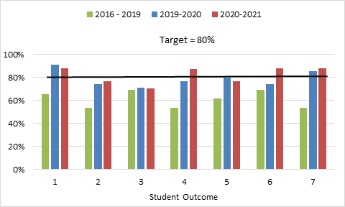
Figure 5-1. Exit Survey Student Outcome Assessment Data.

Course Evaluations – Indirect Assessment
At the end of each semester, students are asked to complete an evaluation measuring the outcomes of the course and the effectiveness of the instructor. The students rank (on a 1-6 scale) how well the intended ABET Student Outcomes were achieved for that course. Figure 5-2 summarizes course evaluation data for this review cycle. Data are not presented for the 2017-2018 academic year because they were not collected in course evaluations that year.
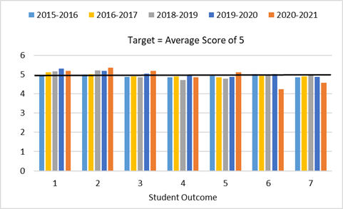
Figure 5-2. Course Evaluation Student Outcome Assessment Data.

Because there is significant overlap with Civil Engineering degree requirements and Construction Engineering degree requirements, course evaluations since the 2016-2017 academic year include feedback from students enrolled in the Construction Engineering degree. It is not possible to separate the students by program in the course evaluations. However, for the time period represented, there is only one student pursuing the Construction Engineering degree who is not simultaneously completing the Civil Engineering degree. This means that the course evaluation data are representative of the students completing the Civil Engineering degree.
Course Level Assessments – Direct Assessment
As discussed and summarized in Table 5.1.3, most student outcomes were subdivided into two or three performance indicators to better assess all components of the intended Student Outcome. The performance indicators are directly assessed by faculty using student coursework. This assessment is meant to be completed every semester for each class, and documented in a memo, with examples of student work included to support the assessment. These materials are stored in a common electronic repository for all faculty members to review. Figure 5-3 contains an example of the documentation completed by a faculty member to assess Student Outcome #2 (Design), performance indicator C (Applies design and evaluates the ability of design to meet needs) in CVEEN 5420 – Open Channel Flow.
As with the course evaluation data, because there is overlap with students enrolled in the Civil Engineering degree and Construction Engineering degrees, there is overlap in the course-level assessment of student outcomes. Students were not separated by major in the faculty’s evaluation of student performance. As stated previously, for this review period there is only one student pursuing the Construction Engineering degree who is not simultaneously completing the Civil Engineering degree. This means that the course-level assessment data are representative of the students completing the Civil Engineering degree. Course-level assessments will be separated by degree beginning fall 2021.
Table 5.1.5 summarizes the years that course-level assessment data were collected for each Student Outcome during this review cycle. For academic years 2015-2016 through 2018-2019, Student Outcomes a-k were assessed by faculty. Beginning in the 2019-2020 academic year, Student Outcomes 1-7 were assessed. Assessment data collected using Student Outcomes a-k were mapped to Student Outcomes 1-7 using the relationships outlined in Table 5-1.
Civil engineering courses have been mapped to each outcome. This is depicted in Table 5.1.5 and Table 5.1.6. Table 5.1.4 illustrates the relationship between a Civil Engineering course and Student Outcomes a – k. Table 5.1.6 illustrates the relationship between a Civil Engineering course and Student Outcomes 1-7 assessed during the 2019-2020 and 2020-2021 academic years.
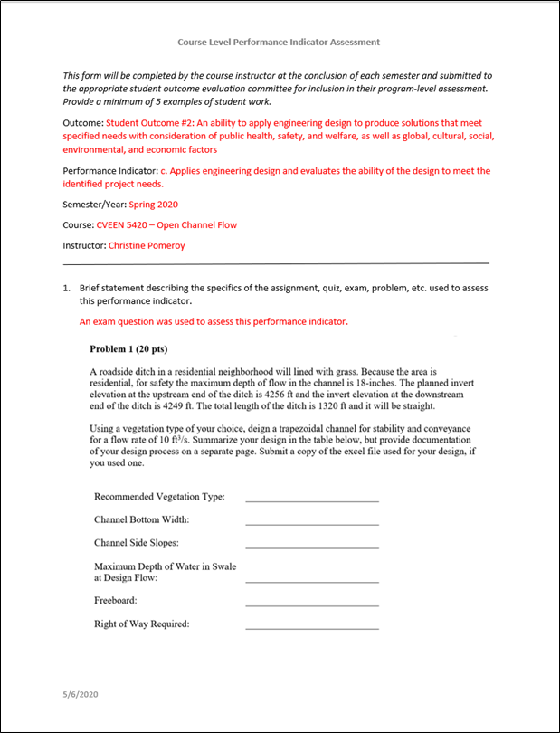
Figure 5-3a. Course Level Performance Indicator Assessment for Student Outcome 2c for Open Channel Flow – Spring 2020. Page 1/2.
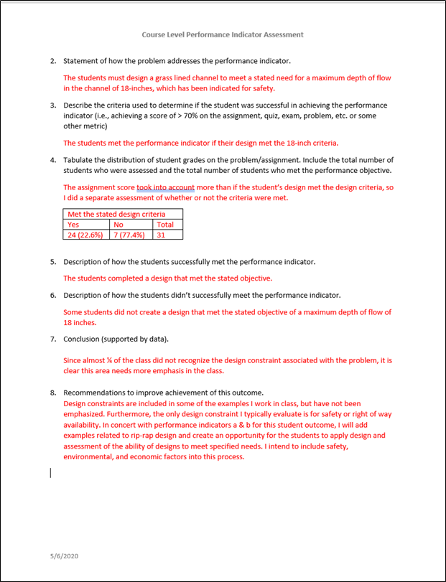Figure 5-3b. Course level performance indicator assessment for Student Outcome 2c for Open Channel Flow – Spring 2020. Page 2/2.

Table 5.1.5: Student Outcome Data Collected from Course Level Assessments Department of Civil & Environmental Engineering
Student Outcomes | 2015-2016 | 2016-2017 | 2017-2018 | 2018-2019 | 2019-2020 | 2020-2021
1. An ability to identify, formulate, and solve complex engineering problems by applying principles of engineering, science, and mathematics |  |  | X | X | X | X
2. An ability to apply engineering design to produce solutions that meet specified needs with consideration of public health, safety, and welfare, as well as global, cultural, social, environmental, and economic factors |  |  | X | X | X | X
3. An ability to communicate effectively with a range of audiences (Technical and Public Audiences) |  |  | X | X | X | X
4. An ability to recognize ethical and professional responsibilities in engineering situations and make informed judgments, which must consider the impact of engineering solutions in global, economic, environmental, and societal contexts |  |  | X | X | X | X
5. An ability to function effectively on a team whose members together provide leadership, create a collaborative and inclusive environment, establish goals, plan tasks, and meet objectives | X | X | X | X | X | X
6. An ability to develop and conduct appropriate experimentation, analyze and interpret data, and use engineering judgment to draw conclusions |  |  |  | X | X | X
7. An ability to acquire and apply new knowledge as needed, using appropriate learning strategies |  |  |  | X | X | X

Table 5.1.6: Relationship of Civil Engineering Courses to Student Outcomes A-K. Department of Civil & Environmental Engineering
 | (a) math, sci. engr. | (b) experi- mentation | (c) design | (d) teams | (e) engr. problems | (f) prof. & ethical | (g) communi- cations | (h) impact of solutions | (i) life-long learning | (j) contemp-orary issues | (k) engr. tools
CVEEN 1000 Introduction |  |  |  |  |  | X | X | X | X | X
CVEEN 1400 CAD |  |  |  |  |  |  | X |  |  |  | X
CVEEN 2000 Seminar |  |  |  |  |  | X |  | X | X | X
CVEEN 2010 Statics | X |  |  |  | X
CVEEN 2140 Strength of Materials | X |  |  |  | X
CVEEN 2300 Engineering Economics |  |  |  |  | X
CVEEN 2310 Probability and Statistics | X |  |  |  | X |  |  |  |  |  | X
CVEEN 2750 Computer Tools |  |  |  |  | X
CVEEN 3100 Technical Communication |  |  |  |  |  | X | X | X | X | X
CVEEN 3210 Structural Analysis | X |  |  |  | X |  |  |  |  |  | X
CVEEN 3310 Geotechnical Engineering | X |  |  | X |  |  |  | X
CVEEN 3315 Geotechnical Engineering Lab |  | X
CVEEN 3410 Hydraulics | X |  |  | X |  |  |  | X |  |  | X
CVEEN 3415 Hydraulics Lab |  | X
CVEEN 3510 Civil Engineering Materials | X | X |  | X | X |  |  |  |  | X
CVEEN 3520 Transportation Engineering | X |  |  |  | X |  |  | X |  |  | X
CVEEN 3610 Environmental Engineering | X |  |  |  | X |  |  | X |  |  | X
CVEEN 4910 Prof. Practice and Design |  |  | X | X |  | X | X |  | X | X
CVEEN 4221 Concrete Design I |  |  | X
CVEEN 4222 Steel Design I |  |  | X
CVEEN 5210 Structural Analysis II | X |  |  |  | X
CVEEN 5220 Concrete II | X |  |  |  | X
CVEEN 5230 Steel II | X |  |  |  | X
CVEEN 5240 Reinforced Timber/Masonry | X |  |  |  | X
CVEEN 5305 Intro. to Foundations Eng. |  |  | X
CVEEN 5410 Engineering Hydrology | X |  |  |  | X
CVEEN 5420 Open Channel Flow |  |  | X
CVEEN 5500 Sustainable Materials | X |  |  |  | X
CVEEN 5510 Highway Design |  |  | X
CVEEN 5560 Transportation Planning | X |  |  |  | X
CVEEN 5570 Pavement Design |  |  | X
CVEEN 5605 Water/Wastewater Treatment |  |  | X
CVEEN 5610 Water Chemistry | X |  |  |  | X

Table 5.1.7: Relationship of Civil Engineering Courses to Student Outcomes 1-7. Department of Civil & Environmental Engineering
 | (1)  Eng. Problems | (2)  Eng. Design | (3)  Communication | (4)  Ethics | (5)  Teams | (6)  Experiments | (7)  Lifelong Learning
CVEEN 1000 Introduction |  |  | X | X | X |  | X
CVEEN 1400 CAD |  |  | X |  |  |  | X
CVEEN 2000 Seminar |  |  |  | X |  |  | X
CVEEN 2010 Statics | X |  |  |  |  |  | X
CVEEN 2140 Strength of Materials | X |  |  |  |  |  | X
CVEEN 2300 Engineering Economics |  |  |  | X |  |  | X
CVEEN 2310 Probability and Statistics | X |  |  |  |  |  | X
CVEEN 2410 Geomatics |  |  |  |  |  |  | X
CVEEN 2750 Computer Tools | X |  |  |  |  |  | X
CVEEN 3100 Technical Communication |  |  | X | X | X |  | X
CVEEN 3210 Structural Analysis | X |  | X | X
CVEEN 3310 Geotechnical Engineering | X
CVEEN 3315 Geotechnical Engineering Lab |  |  |  |  |  | X
CVEEN 3410 Hydraulics | X |  | X | X | X
CVEEN 3415 Hydraulics Lab |  |  | X |  | X | X
CVEEN 3510 Civil Engineering Materials | X |  |  | X
CVEEN 3515 Civil Engineering Materials Lab |  |  |  |  |  | X
CVEEN 3520 Transportation Engineering | X |  | X | X |  |  | X
CVEEN 3610 Environmental Engineering | X |  |  | X
CVEEN 3615 Environmental Engineering Lab |  |  |  |  |  | X
CVEEN 4900 Prof. Practice and Design I |  | X | X |  | X
CVEEN 4910 Prof. Practice and Design II |  | X | X | X | X |  | X
Civil Engineering Technical Electives
CVEEN 4221 Concrete Design I |  | X
CVEEN 4222 Steel Design I |  | X
CVEEN 5210 Structural Analysis II | X |  |  |  |  |  | X
CVEEN 5220 Concrete II | X |  |  |  |  |  | X
CVEEN 5230 Steel II | X |  |  |  |  |  | X
CVEEN 5240 Reinforced Timber/Masonry | X |  |  |  |  |  | X
CVEEN 5305 Intro. to Foundations Eng. |  | X
CVEEN 5410 Engineering Hydrology | X |  |  |  |  |  | X
CVEEN 5420 Open Channel Flow |  | X
CVEEN 5500 Sustainable Materials | X

Figures 5-4a-h summarize course-level student outcome results for this review period. Results from assessments conducted using Student Outcomes a – k were not mapped to individual performance indicators; therefore, the percent of assessments meeting targets are the same for each performance indicator for the 2016-2019 time periods.

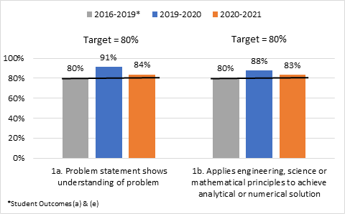
Figure 5-4a. Percent of assessments meeting faculty-specified performance indicator competency criteria for Student Outcome 1.

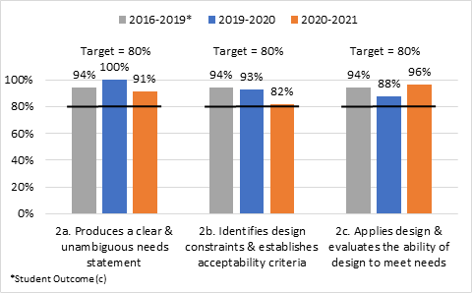
Figure 5-4b. Percent of assessments meeting faculty-specified performance indicator competency criteria for Student Outcome 2.

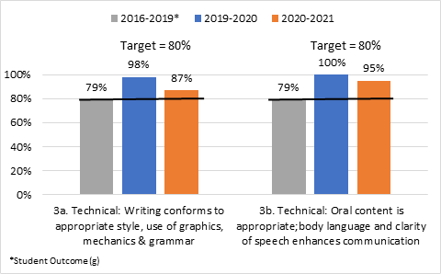
Figure 5-4c. Percent of assessments meeting faculty-specified performance indicator competency criteria for Student Outcome 3 – Technical Audience.
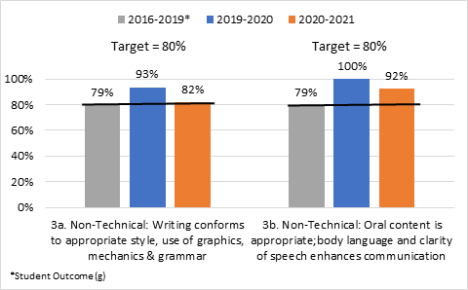
Figure 5-4d. Percent of assessments meeting faculty-specified performance indicator competency criteria for Student Outcome 3 – Public Audience.

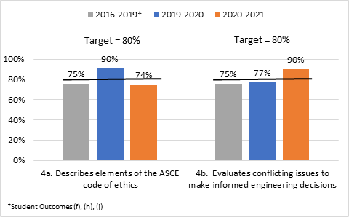
Figure 5-4e. Percent of assessments meeting faculty-specified performance indicator competency criteria for Student Outcome 4.
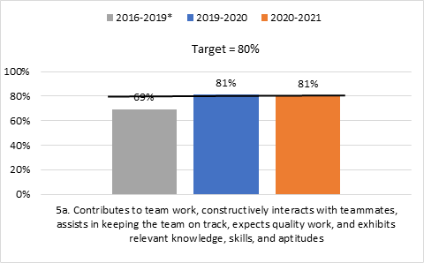
Figure 5-4f. Percent of assessments meeting faculty-specified performance indicator competency criteria for Student Outcome 5.

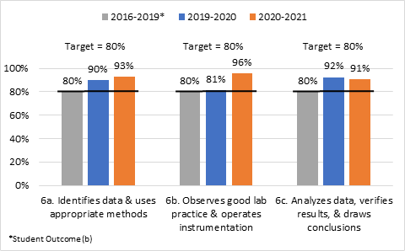
Figure 5-4g. Percent of assessments meeting faculty-specified performance indicator competency criteria for Student Outcome 6.

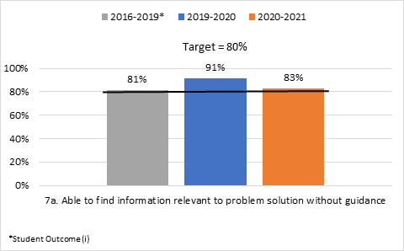
Figure 5-4h. Percent of assessments meeting faculty-specified performance indicator competency criteria for Student Outcome 7.
Summary of Results
Student Outcome 1: An ability to identify, formulate, and solve complex engineering problems by applying principles of engineering, science and mathematics.
During our ABET review period, exit interviews prior to the 2019-2020 academic year indicated that graduating students did not feel confident in their ability to apply engineering principles. Beginning with the 2019-2020 academic year exit interview responses had an increasing percentage of graduating students at or above the Department-established goal of selecting their perceived achievement at a value of four or higher. From 2016-2019 the percent of graduating students who met or exceeded this established target was 80%. In the 2019-2020 academic year, this measure increased significantly. This mirrors the data collected in the course evaluations. These evaluations show in the 2015-2016 academic year a low percent of graduating students selected their perceived achievement of this outcome at a value of four or higher, followed by steady improvement in this measure up to the 2019-2020 academic year. Following the 2019-2020 academic year both of these indirect assessment methods show a decrease in the percent of students rating their perceived ability to achieve the specific outcome.

The direct Course Level Assessment, while meeting the faculty-specified performance indicator, shows a similar trend where improvements are seen beginning in the 2019-2020 academic year. It should be noted that prior to the 2019-2020 academic year the assessment was based on outcomes a-k. Furthermore, it is unknown how much the COVID-19 pandemic influenced the 2020-2021 results.
Student Outcome #2: An ability to apply engineering design to produce solutions that meet specified needs with consideration of public health, safety, and welfare, as well as global, cultural, social, environmental, and economic factors
Figure 5-1 illustrates that through the current review period there was an increasing trend in percent of graduating students indicating their perceived ability to meet Outcome 2. In spite of this increasing trend, the percentages do not meet the established department target of 80% of students. Course evaluations for classes that address Outcome 2 show the students rated the overall effectiveness of these courses as 5 out of 6, surpassing the department targeted value (of 5) in the 2019-2020 academic year followed by continued increase. When compared to the course-level evaluations, there seems to be a difference in results since the performance exceeds the faculty-specified performance indicator. This points to the differences between the perception of the students and the evaluation done by the instructors. The reason for the difference between the student and faculty perception of competency in this outcome must be further investigated. The ABET/Undergraduate Committee suspects this discrepancy may be due to the fact that the indirect assessments measure the outcome as an unspecified engineering design, while the course direct assessment is based on a specific design done during the semester as part of the class.
Student Outcome #3: An ability to communicate effectively with a range of audiences
The exit interview assessment shows that the graduating students do not feel confident about their ability to communicate effectively. During the evaluation period, the 80% target is not met. The course evaluations do not meet the target score measuring course effectiveness until the 2019-2020 academic year. The direct course-level assessment shows that there were concerns when measured on the prior a-k outcomes (outcome (g)) but significant improvements began in the 2019-2020 academic year following the transition to assessment criteria 1-7. In other words, both the indirect and the direct assessment point to a steady improvement in how this outcome has been met.
Student Outcome #4: An ability to recognize ethical and professional responsibilities in engineering situations and make informed judgments, considering the impact of engineering solutions in global, economic, environmental, and societal contexts

The exit interview assessment shows that through the evaluation period there has been a consistent improvement in the students’ perception of their ability to meet this outcome with values above the target during the 2020-2021 academic year. This is part of the trend that is seen in the other outcomes where the old a-k outcomes (outcomes (f), (h), and (j)) were not meeting the 80% target but improvements are seen once the 1-7 outcomes are assessed. The course evaluations show that the target value of 5 is not met during the evaluation period and no trend (up or down) is observed. The course-level performance assessment shows that, overall, the performance exceeds the faculty-specified performance indicator. However, when the results are broken into sub-outcomes (i.e., 4a and 4b), there are academic periods where the outcome does not meet the target value of 80%. For example, there were improvements in 4a during the 2019-2020 academic year but a drop during the 2020-2021 academic year.
Student Outcome 5: An ability to function effectively on a team whose members together provide leadership, create a collaborative and inclusive environment, establish goals, plan tasks, and meet objectives
The indirect methods of assessment indicate that this outcome does not always meet the target values. Exit interviews do not meet the target values of 80% during the evaluation period; similarly, the course evaluations have average responses below the target value of 5 up until the 2020-2021 academic year. The direct assessment was done using the CATME Online tool, which provides objective data. It shows that while the target was met in an overall sense, specifically looking at Outcome 5a, the target was not met prior to the 2019-2020 academic year. A closer look at semester-specific data from Fall 2015 to Spring 2019 showed that there were two semesters of specific concern: Spring of 2017 and Fall of 2017. During both semesters, approximately 40% of assessment data points were below the faculty-specified threshold for performance acceptability. Since 2019-2020 the results show the outcome is above the faculty-specified performance indicator.
Student Outcome 6: An ability to develop and conduct appropriate experimentation, analyze and interpret data, and use engineering judgment to draw conclusions
This outcome has shown steady improvement based on the exit interviews conducted during the evaluation period, although the target value of 80% was not met until the 2020-2021 academic year. The course evaluations show that the assessment of this outcome is consistent and it meets the target average score of 5 during the evaluation period with the exception of the 2020-2021 academic year. This is, perhaps, the result of the changes that needed to be implemented due to COVID restrictions. While students were still required to perform in-person experiments during the lab, they were limited in group sizes or in some cases in their operation of certain equipment (again due to COVID restrictions). The direct assessment shows that this outcome meets the faculty-specified performance indicator. Most labs, where this outcome is primarily assessed, have undergone significant improvements throughout the evaluation period.
Student Outcome 7: An ability to acquire and apply new knowledge as needed, using appropriate learning strategies
When this outcome was evaluated under the a-k system (outcome (i)), the exit interviews show that, from the students’ perception, the outcome was not met. This changed during the 2019-2020 and the 2020-2021 academic years when significant improvements were seen and exceeded the target value of 80%, The course evaluations show an average close to 5 and a decrease in the average scores during the 2020-2021 academic year. This means that the exit interviews and the course evaluations do not follow the same trend. The reason for the discrepancy is unclear, although it is postulated that change in perception relates to the change of the outcome from (i). Students will have a recognition of the need for, and an ability to engage in life-long learning to the language for Student Outcome 7, which may be more relatable. Direct assessment based on the faculty-specified performance indicator shows that the students meet the requirement since 80% of the assessments meet competency during the evaluation period. However, a decrease from 91% to 83% is noted between the 2019-2020 and the 2020-2021 academic years. This result is consistent with the indirect course evaluation data. As more data is collected, the trend will be analyzed.
See Appendix L for interim and 7-year learning outcome assessment reports.
5.2 Outcomes assessment feedback
Curricular Decision Process
The Department uses a two-prong process to create updates to the degrees and minor. The first process is utilizing the Undergraduate and Graduate Committees in proposing changes that are needed to adjust the overarching curriculum requirements. These committees bring forward changes that are needed to modernize curriculum, meet accreditation guidelines, and other needs as identified by the committees.
The committees can consult individual faculty, Faculty Groups, Industrial Advisory Board, and Student Committees to format the changes needed to the curriculum. The changes will be formally presented at a faculty meeting that allows open discussion and dialogue. If changes are needed, the committee will consider and bring forward as changes are made. All changes made to the curriculum will be done through a faculty vote.
The second process is to address updates to courses within the program. These changes will be made through the Faculty Group Committees (Environmental/Water, Infrastructure, Nuclear and Transportation). The changes that the committee would like to do should be approved at the Group Committee level. The changes that do not require a full faculty vote include the course description, prerequisite* classes, and graduate-level core course requirements. The changes that can be put forward by the committees but need a faculty vote include creation of a course, change of a course number, change of title, and prerequisite* classes.
*Prerequisites for classes that are in the 1000- to 4000-level courses require a vote by the full faculty. This is due to the impact upon department accreditation. Courses 5000-level and higher do not need faculty approval.
Learning Outcomes
Learning Outcomes for the undergraduate program are guided through the Department ABET Accreditation. The outcomes are reviewed through the Undergraduate Committee biannually in consultation with the faculty and Industrial Advisory Board.
The graduate Learning Outcomes are created to accompany the undergraduate ABET Accreditation to continue the mission of the Department. These are created by the Graduate Committee and shall be reviewed by the committee in consultation with the faculty and Industrial Advisory Board.
For both undergraduate and graduate programs, the Learning Outcomes will be voted on by the faculty for implementation into the program.
Review and Assessment Periods
Assessments to the undergraduate classes (5000-level and below) will occur semesterly by the instructor. Assessment will be done through the Learning Outcomes that are assigned to each undergraduate course. A Department-level review will occur annually and discussion on any changes will be addressed annually.
Graduate course assessment (6000-level and higher) will be done at the Group Committee level. Assessment reviews will be done annually by each group for the courses that were taught during the previous academic year.

5.3 Degree completion data

See Tables 5.3.1 and 5.3.2 for master’s and doctoral degree completion/attrition data.

Table 5.3.1: Master’s Degree Completion/Attrition Data Department of Civil & Environmental Engineering
Entering Student Cohort Academic Year | Number of students newly enrolled in master’s programs | Number of students in cohort who left before completing master’s degree | Number of students in cohort who went on to complete master’s degree | Average time to complete master’s degree (years) | Number of students in cohort currently remaining in master’s programs
2014-15 | 29 | 4 | 25 | 2.6 | 0
2015-16 | 27 | 1 | 26 | 2.5 | 1*
2016-17 | 31 | 4 | 27 | 2.4 | 3*
2017-18 | 19 | 0 | 19 | 2.5 | 0
2018-19 | 18 | 1 | 16 | 2.7 | 1
2019-20 | 20 | 0 | 13 | 2.6 | 7*
2020-21 | 18 | 0 | 0# | 2.4 | 18

* ----------- 2015-2016: 1 student still enrolled now PHD
2016-2017: 2 students still enrolled now PhD
2019-2020: 5 students still enrolled in MS; 1 student changed to PhD
# --------- 2020-2021: No graduates yet. Still within reasonable enrollment time.

Table 5.3.2: PhD Degree Completion/Attrition Data Department of Civil & Environmental Engineering
Entering Student Cohort Academic Year | Number of students newly enrolled in doctoral program | Number of students in cohort who left without completing a degree | Number of students in cohort who received a master’s instead of a doctoral degree | Number of students in cohort who went on to complete a doctoral degree | Average time to complete doctoral degree (years) | Number of students in cohort currently remaining in doctoral program
2014-15 | 10 | 0 | 2 | 8 | 5.9 | 0
2015-16 | 7 | 1 | 0 | 6 | 5.9 | 2
2016-17 | 18 | 3 | 2 | 8 | 5.9 | 5
2017-18 | 12 | 0 | 1 | 7 | 6.2 | 4
2018-19 | 16 | 1 | 1 | 2 | 6.1 | 12
2019-20 | 20 | 1 | 0 | 1 | 5.7 | 18
2020-21 | 10 | 1 | 0 | 0 | 6.0 | 9

5.4 Employment
The good news for our students is they are able to get positions within the profession if they would like to work within the field. Most of the undergraduate students are working as interns in their junior year and this year we are finding that many of the sophomores are being hired even with limited civil and construction engineering specific coursework. This does cause a problem for our students as they will work more and take longer to get done with their coursework when we would like them to get done and then work. The high demand for the bachelor degree graduates does cause a problem in showing the need for students to continue their education to a graduate degree.
When reviewing the doctoral placement upon graduation, Appendix M, the largest area that the graduates are going to work within is research, consulting and legal services at 31.9%. The next largest area is 27.5% of the graduates who have gone into academia. This is 18 alumni, and breaking it down more than this currently breaks down to 7 in tenure-track faculty positions and 5 in tenured positions.
The difficult thing for this analysis is that 24.6% of the alumni were not located. Depending on what industry the alumni are working within, this will change the percentage as the pool of graduates isn’t large for the Department.

