2017-2018 LEAP Learning Communities Annual Report

Office of Undergraduate Studies
The University of Utah
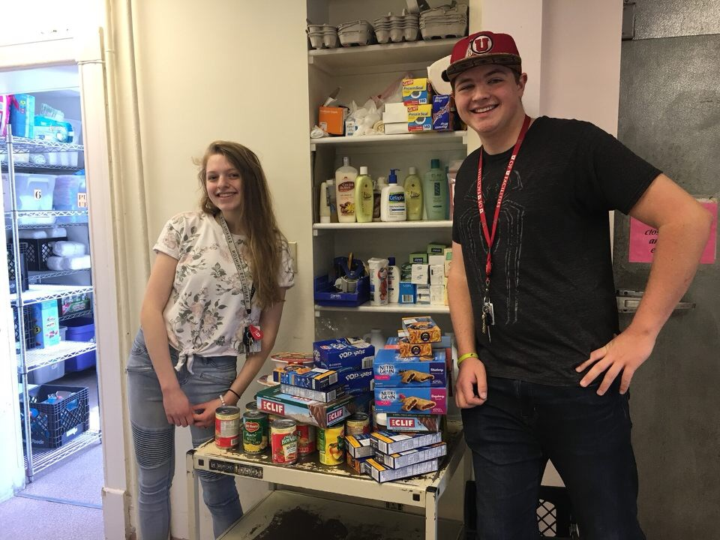
Delaney Mosier was awarded a Sophomore Rise Ivory Homes award to further develop her project around what she learned in the poverty workshops put on by Glenn Bailey on Making it in Utah in Fall 2017.

Prepared and Submitted by:

Steve Maisch Ph.D.,
LEAP Program Assistant Director

Mirassa Diener, Ph.D.,
LEAP Program Director

Liz Taylor,
LEAP Program Executive Assistant

July 1, 2018

Executive Summary
LEAP continues to play an important role in supporting student success at the University of Utah. LEAP is a critical part of the “Utah Pledge,” which is the central organizational principle around student success: 1) Every entering student in a learning community, 2) every student has at least one deeply engaged learning experience, and 3) every student has a Plan to Finish and is supported by students success advocates, mentors and advisors. Over the 2017-2018 academic year, LEAP offered 50 learning community sections for first-year students, enrolling 774 students Fall 2017. We offered 13 multi-year and transfer sections, enrolling 100 multi-year or transfer students Fall 2017. We partnered with the Academic Advising Center, Student Success Advocates, MUSE, the Bennion Center, Capstone Initiatives, New Student and Family Programs, and many colleges (Engineering, Mines & Earth Sciences, Health, Humanities, Law School, Colleges of Medicine, Pharmacy, and Dentistry, College of Nursing, Science, Social and Behavioral Sciences, and Social Work). We developed a new partnership with the REFUGES bridge program with the Center for Science and Mathematics Education for students with refugee status. The REFUGES bridge program, launched in 2013, is for first year students interested in majoring in STEM who have the opportunity to live on campus, attend classes and jumpstart their college experience. REFUGES bridge students now enroll in Math 1050 and LEAP in the summer while living on campus, and maintain their cohort into the academic year.
Unadjusted OBIA data indicated that LEAP students continue to be retained at higher rates and show higher 6-year graduation rates than non-LEAP students.

LEAP Program Description

LEAP is a year-long learning community for entering University students. It consists of two three-credit-hour courses – one fall semester, one spring semester – taken with the same professor and classmates, allowing students to build community. LEAP’s two classes typically fulfill the University’s diversity requirement and two general education requirements (one in social science and one in the humanities, although Health LEAPs
fulfill two humanities requirements and the diversity requirement) and are linked to optional classes for LEAP students in writing, library research, and major selection. Community Engagement Learning credit is offered in many sections of LEAP.

LEAP’s mission is four-fold:

- To promote and implement scholarship and campus and community engagement for first-year students through an integrated, interdisciplinary, and collaborative teaching and learning community;
- To attract and retain a diverse student population;
- To engage students in an interactive exploration of diversity issues both
in the classroom and through community outreach.
- To get first-year students off to a successful start in college, help them feel they belong at the University of Utah, and encourage their timely progress into a major and toward graduation.

A Program Overview for the Year

The following overview uses ex-post enrollment data from the Registrar’s Office and represents the number of students enrolled through each semester. In the fall, the LEAP program enrolled a total of 874 students in 26 first-year sections, two sections beyond the first year in Pre-Law LEAP, 3 sections beyond the first year of Health Sciences LEAP and one section of Transfer LEAP. In the spring, the LEAP program enrolled a total of 526 students, 459 students in 23 first-year sections and 60 in Pre-Law and Health Sciences sections beyond the first year.

Fall-spring retention dropped some in 2018 relative to 2017. It should be noted here that fall enrollment in 2016 was 507. Some of this drop could be attributed to large enrollment in ELEAP and Transfer LEAP in the fall.

In addition, LEAP offered the following courses for the2017-18 academic year:
- LEAP 1050: Major Selection, a course taught in the spring by University College Advisors, for 14 students in 3 sections.
- LEAP 2002: Peer Advisor Seminar elected for credit by 5 Peer Advisors.
- LEAP 1060-001: library research add-on for 108 students.
- Five sections of Writing 2011 (three in the fall and two in the spring) were offered. There were 62 students in Writing 2011 in the fall and 30 students in 2011 in the spring. Two sections of Writing 1010 were offered in the fall. There were 46 students enrolled in Writing 1011 in the fall. In the past these sections were reserved for LEAP students exclusively but due to low enrollment they were opened to all students

Plans for 2018-2019:
- Due to low enrollment, Writing 1011 and 2011 will not be offered.
- Form a committee with LEAP faculty for assessing Critical Thinking.
- Dr. Jennifer Bauman will be offering one section of Fine Arts LEAP as an online course.
- A technology focused IR course will be developed for Spring 2019-2020 academic year.

Changes and Developments in LEAP

New Teaching and Administrative Assignments
- Dr. Steve Maisch taught a two semester Pre-STEM LEAP course
- Dr. Meg Harper created a new curriculum for Science LEAP

New Programs and Partnerships
- LEAP faculty and a LEAP senior peer advisor collaborated with academic librarians to further assessment efforts in Information Literacy. This work resulted in receiving a group teaching grant (See Appendix 2) to purchase the Standardized Assessment of Information Literacy Skills, aka Project SAILS. This collaboration resulted in a presentation at the Association for the Assessment of Learning in Higher Eduction (AALHE) conference in June 2018 and conference paper.
- LEAP partnered with the Center for Science and Mathematics Education for the Refuges Bridge Program.
- Dr. Meg Harper developed relationships with College of Science Advisors for this course.
- Dr. Jennifer Brown partnered with the College of Social and Behavioral Sciences Advisors to Introduce Students to the college Capstone projects and aligned these with their final LEAP research projects.

- Program Assessment

Direct Assessment:

In the spring of 2016 LEAP constructed an assessment plan to assess the LEAP Learning Outcomes; Critical Thinking, Information Literacy and Teamwork. In addition to LEAP specific Learning Outcomes, LEAP worked with other learning communities on campus to develop assessment measures for learning communites in general. An example assignment and description of the Learning Outcomes the assignment is intended to satisfy is given in Appendix: 3. The LEAP specific Learning Outcomes will be assessed using established AAC&U rubrics.

Indirect Assessment: The Skyfactor Report

For the past 9 years, LEAP has been administering a survey to spring semester students designed by Educational Benchmarking Incorporated (EBI) now known as Skyfactor. This survey organizes 100+ questions into 23 “factors” (summarizing clusters of related questions). Scores on the “factors” are the mean value of student responses, from 1 – 7 with a score of 1 representing “not at all” and a score of 7 representing “significantly”.

Skyfactor collects survey results from 26 different Institutions in the fall and the spring semester. For reasons of comparison these Institutions are separated into two groups, “Carnegie Class” and “All”. The “Carnegie Class” is a group of very high research activity Universities. These are the University of Alabama Birmingham, University of South Carolina and the University of Utah. “All Institutions” totals 26 Universities. These are available on request.

As noted above, the LEAP Program is a year long learning community and as such spans two semesters. For this reason LEAP administers the survey in the spring semester while the other Institutions in this report administer the survey in fall semester. For purposes of this report, the LEAP 2018 results, spring 2018 will be compared with the fall 2017 results for the other Institutions. We are currently awaiting the results of our Spring survey from Skyfactor.

Learning Community Assessment

LEAP has worked with Honors, BlockU, Diversity Scholars and Humanities Scholars to “develop a systematic approach to assessing the student learning that occurs in the context of learning communities.” (See Appendix for report). In this report, three integrative learning outcomes were constructed. These are:

- Intellectual Connections: Measures student capacity for making connections among disciplines, experiences, perspectives, etc.

- Reflection/Self-Assessment Connections: Develops ability to self-assess (e.g., introspection, directional learning, self-authorship).

- Community Connections: Anchoring students to campus and community, e.g., feeling they belong, knowledge of where to find resources, etc.

We conducted a survey of 355 of our students in Fall 2017 to provide an initial assessment on how we are addressing these outcomes. The results were as follows:

The results of the survey indicate that students perceive that we are meeting the learning outcomes for learning communities by helping students make connections across courses, on and off campus, and self-assessment connections. We will use these results to refine our curriculum.

Learning Communities First Semester Survey Assessment from Fall 2017:

Representative quotes from students:
“Learning how to be a critical thinker has helped me in both my biology class, and in my writing class. In my writing class we are researching topics that are important to us, and taking my skills that I have learned in my LEAP class has helped me to form better arguments while still keeping an open mind. Learning about racial discrimination in LEAP has corresponded to my biology class, and helped me fully realize that on the inside everyones' body works the same way. “

“After evey liberary sesion, I knew more about how to find resources, and how to write an article. It's helpful for my other classes, such as the disscussion in ETHNC, and assignment in ARCH.”
“LEAP helped me understand how to perform effective research for my writing class. The library sessions were very helpful, and I'm able to provide much more effective citations now. Additionally, a lot of the things we've learned correlate and expound upon subjects in my hisotry course, and I'm also able to write better for that class.”

“The idea of technologies having ideology was applicable to my writing class in which we discussed and wrote about social media. Beyond that, I also connected it to my extracurricular study of game design because it brought a new perspective on how my games might affect people. “

”LEAP has helped me in my work. I work at a retail store and come across people of all races and cultural backgrounds. LEAP has helped me to keep and open mind when working with these people, and to not lose my patience with them when they act differently from me. “

“I learned how to work with a group and organize and strategize with them. This is a critical life skill for engineers as many will likely be working with groups, and knowing how to work well with a group is essential.”

”The interview with an engineer assignment was a fantastic opportunity to get out and network in the engineering community. It led to a very large opportunity for me.”
“It help me make life long friends on and off campus that are going to have my back no matter what. Also it help me get a great connection with people at the Sill Center and the Sill Center has so many resources for students.”

“I know all of my LEAP classmates, and I feel like I am a part of that community. ’

We included these items again on our Spring 2018 Skyfactor survey, and will report the results when they become available.

Peer Advisor Program

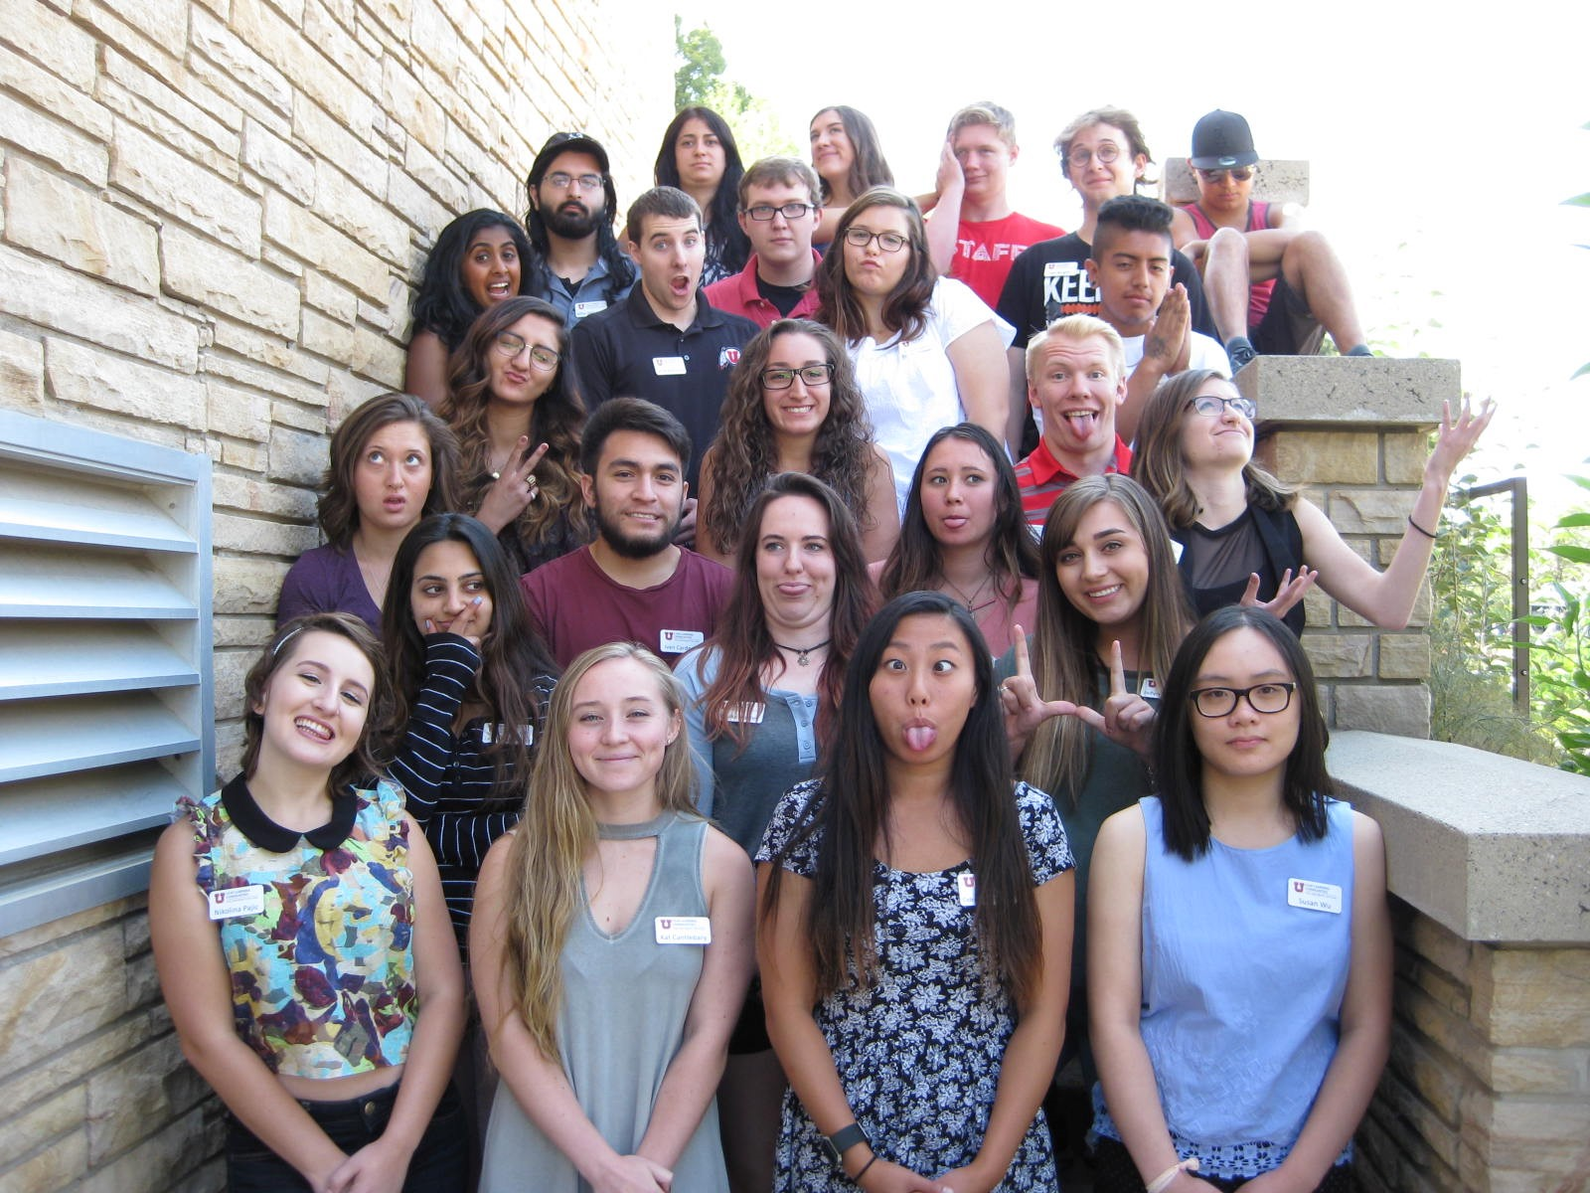2017-2018 Peer Advisers
See the Annual Report for AY 2005-2006 for a description of the Peer Advisor Program. (http://www.leap.utah.edu/media/leap_05-06_report.pdf)
The Peer Advisor program had another very successful year under Dr. Carolan Ownby’s leadership. This year’s cohort of Peer Advisors numbered 26: one per LEAP section including two Senior Peer Advisors. They met twice a month as a group, each led by one of two Senior Peer Advisors and meeting on a staggered schedule. While the PA’s met every other week, Dr. Ownby thus met with one group every week. Membership in the two groups was scrambled at the semester.

Peer Advisors play an important role in the LEAP program because they build academic success through office hours and by arranging study groups. They help students’ build community, and they identify avenues for meaningful engagement. The Peer Advisor program also provides leadership opportunities.
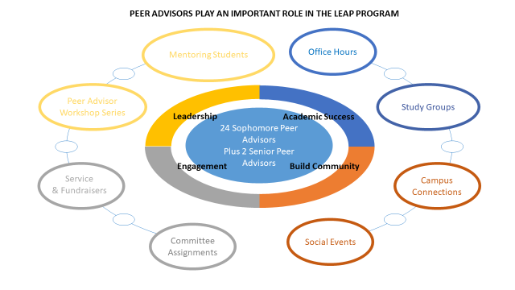
- Program Activities
LEAP sponsored the following activities in 2017-18
- Peer Advisor Workshop to prepare the 2017-18 Peer Advisors, August 17 and 18, 2016.
- Reception for LEAP students, Sill Center, August 29, 2017.
- Glenn Bailey’s poverty workshops, September 6 and September 7, 2017.
- LEAP Convocation featuring Dr. Mark Matheson, September 6, 2017.
- MUSE brought Margot Lee Shetterly, author of Hidden Figures, March 22, 2017.
- Nineteen LEAP students presented their research at the Undergraduate Research Symposium, April 11, 2018.
- Pre-Law LEAP luncheon, April 13, 2018.
- LEAP faculty help register New University Scholars and other pre-registering students for classes, May 19, 2018.

Community Engaged Learning

- Pre-Law LEAP partnerships with the U law admissions office and its Pro-Bono clinics have continued, as have students doing internships with State Senator Todd Weiler. Students performed 90 hours of community service in the Pro-Bono clinics and with the Rocky Mountain Innocence Project and the Governor’s Office of Economic Development.
- The LEAP PA’s continued their partnership with Northwest Middle School, hosting about 90 students for a morning campus experience. The PA’s also continued their partnership with Crossroads Urban Center for Fall and Spring.
- Dr. Carolan Ownby’s 1100 and 1101 LEAP students completed 25 hours in the fall and spring.
- Delaney Mosier, a student in Dr. Meg Harper’s Science LEAP class, received the Sophmore Rise Ivory Homes Deeply Engaged Learning Experience Award for 2018-19. This award is for her project UShare, an inititative that will encourage students to donate unused money from their meal plans to buy food for Crossroads Urban Center. Her interest in developing this project arose from her participation in Glenn Bailey’s Making is in Utah workshop in September 2017 and after donating food and water purchased from her unused meal plan in May 2018.
- Dr. Jennifer Brown’s Fine Arts LEAP and Senior Peer Advisor, Artemis Sefandonakis raised the most money for the LEAP Crossroads Urban Center Fundraiser both fall and spring semester.

Advising
LEAP continued an effective partnership with University College advising this year, with the aim of helping students investigate and choose majors.
- LEAP faculty met with advisors from specific colleges: the college of science, the college of engineering, the college of nursing, the college of health, the college of social and behavioral sciences, and the college of fine arts.
- Dr. Marissa Diender presented to UAC three times and is completing a practicum with Bobbi Davis, the coordinator of advising for the college of social and behavioral sciences, for her EdD degree.
- Three sections of a one-credit hour class, LEAP 1050, taught by Academic Advising Center Advisors on the process of major selection, were offered again this spring for LEAP students.

LEAP’s Library Partnership
Since 1995, LEAP has partnered with instructional librarians to introduce students to library research strategies and techniques. This partnership continued in 2016-17, with each LEAP section visiting the library for ten instructional sessions over the course of the two semesters. Librarians worked with each LEAP instructor to tailor library sessions to the particular needs of the class. Students who successfully completed eight of the ten exercises assigned at these meetings could earn an extra hour of credit for a course in library research, LEAP 1060.
In 2017-18 Dale Larsen (library) and Rebecca Larsen (LEAP) functioned as the library liasons.

Partnership with the Writing Program
For 2017-18 LEAP revised our partnership with the Department of Writing and Rhetoric to offer three Writing 2011 classes for the fall of 2017, all three hybrids of on-line and face-to-face, and two sections of Writing 1011, both face-to-face. There are no current plans for LEAP-only writing classes in the spring of 2018.

LEAP Advisory Boards
The LEAP Policy Board met twice this academic year: on October 31, 2017 and March 9, 2018. See Appendix for the Agendas for these meetings and the Roster for the meeting.

10. Student Recruitment and Program Outreach
- LEAP faculty met with advisors from specific colleges: the college of science, the college of engineering, the college of nursing, the college of health, the college of social and behavioral sciences, and the college of fine arts.

Milestones and Awards

A Few Notable Student Achievements
- Delaney Mosier, a student in Dr. Meg Harper’s Science LEAP class, received the Sophmore Rise Ivory Homes Deeply Engaged Learning Experience Award for 2018-19.
- Three Pre-Law LEAP students have been accepted at Quinney Law School for the fall. One Pre-Law LEAP graduate was elected President of the Quinney Minority Law Student Association.
- Peter Ahorukomeye, a Health Sciences LEAP student, was accepted into multiple medical schools and is currently deciding which one to attend.
- Annwin Chen was a Health Sciences LEAP student and is pursuing her Doctor of Pharmacy at the University of Utah College of Pharmacy.
- Naveen Rathi will attend medical school at the University of Utah School of Medicine.

LEAP Scholarship and Award Recipients for Academic Year 2018-19

Approximately $50,500 was given out in scholarships and awards to:
Ruth E. Bamberger and John E. Bamberger Memorial Foundation & Roger Leland Goudie Foundation($2000)
Alexander Acuna
Debora Brito de Andrade
Krystal Butamante
Maya Correa
Dego Gabo
Jhorg Garcia
Elizaeth Izampuye
Isabella Lopes
Ngoc Pham
Sinndy Rios
Yutzil Roman
Angel Sanchez
Ana Zamora

Roger Leland Goudie Foundation and Henry W. & Leslie Eskuche Foundation ($2000)
Carlo Cardozo
Andre Cruz Delgadillo
Amy Nguyen

Frost Award for Outstanding Peer Advisor ($500)
Artemis Sefandonakis
Asha Davenport Memorial Scholarship ($2000)
Lilly Kanishka
Michelle Ngo

Castle Foundation
Nicole Mortensen

Parent Fund ($2,000)
Marela Landeo

Lindquist Moore ($2000)
Logan Draper
Jadyn Applonie
Brooke Hadley
Gillian Stucki
Artemis Sefandonakis

Faculty Activities and Achievements, including conference presentations
- Dr. Meg Harper, as Chaptor Advisor for Phi Eta Sigma was involved in two community service projects that benefitted Salt Lake City’s Homeless Youth Center and another project targeted to Utah’s National Guard serving overseas. For their donations, the University of Utah chapter received recognition from the U.S. Congress.
- Dr. Marissa Diener received the CSBS Excellence in Mentoring award.
- Dr. Jennifer Brown was nominated for the University of Utah Beacons of Excellence Teaching Award.
- Dr. Brown (chair) along with Dr. Rebecca Larsen and Dr. Steve Maisch formed a committee on Information Literacy assessment and coordinated the successful proposal, conference presentation and submission to the Proceedings of a Panel Presentation, entitled “Library Partnership and Assessment: Multiple Stakeholder Evaluation in an Academic Co-Teaching Environment” on the LEAP/Library partnership for the Association for the Assessement of Learning in Higher Education (AALHE) conference in Salt Lake June 4-7, 2018.
- Dr. Carolyn Bliss was granted Emerita status, was named an inaugural MUSE Professor, published a book review in Christianity and Literature and gave a paper and chaired a session at the Annual Conference of the American Association for Australasian Literary Studies in New York City, April 6.
- Dr. Mike White published a poetry collection, Addendum to a Miracle and did readings in Salt Lake City and Washington DC to promote the book.
- Dr. Ann Engar was named a favorite professor, Alpha Chi Omega and was nominated by faculty and students for the Faculty Career Innovation Award and Carreer Services Recognition Award.
- Dr. Engar’s publications this year:

Lulu G. Porter, Dr. Bella Gemell, Alice Louise Reynolds, Elizabeth A. Hayward, biographical sketches in Online Database of NAWSA Suffragists, 1890-1920. Ed. Thomas Dublin. Center for the Historical Study of Women and Gender, Binghamton University.

“Pure Religion and True Social Service: Amy Brown Lyman,” Women of Faith in the Latter-Days. Ed. Brittany Chapman Nash and Richard E. Turley. Deseret Book 4:134-151.

University Service by LEAP Faculty

Dr. Meg Harper continued her position as Chapter Advisor for Phi Eta Sigma National Freshman Honor Society and was a member of the University Studies Committee which evaluates proposals for the BUS Degree.
- Dr. Meg Harper, Dr. Marissa Diener, Dr. Jennifer Brown, Dr. Jennifer Seagrave, Dr. Ann Engar participated in the AAC&U Institute on High Impact Learning Practices in June 2018.
- Dr. Jennifer Brown participated by invitation to the Utah System of Higher Education Outreach and Access Retreat, May 11, 2018 at the Leonardo, Salt Lake City.
- Dr. Jennifer Brown attended the 11th International Conference on e-Learning and Innovative Pedagogies with support from LEAP to learn about and incorporate best practices and cutting edge pedagogies into her new online course.
- Dr. Carolyn Bliss attended MUSE events, served on the Bennion Center Scholars Committee, and worked on a report on outcomes for Health Sciences LEAP.
- Dr. Ann Engar served as an Academic Senator, served as an Undergraduate Council Honors Representative, an Honors Policy Board Faculty Representative, Honors Application Reading Committee. Dr. Engar served as Muse Professor, on the LEAP Policy Board, LEAP Diversity Scholarship Committee, LEAP Faculty Development Committee, presented at the Pre-Law Student Society in September, at the Undergraduate Research Education Series in October, and at Passageways to Law in February. On the National level, Dr. Engar is also a Distinguished Bibliographer for the Modern Language Association International Bibliography.

List of Appendices

- LEAP Learning Communities Budget Narrative Excerpts for 2018-2019
- Project SAILS group teaching grant application, summary, narrative
- High Impact Practices (June 19-22, 2018), AAC&U Summer Institute Proposal
- LEAP Policy Board Members and Agendas

1. LEAP Learning Communities Budget Narrative Excerpts for 2018-2019
President Pershing had 4 strategic goals: promote student success, generate knowledge, engage communities, and ensure the long-term vitality of the University of Utah. The LEAP Learning Communities program fits primarily with the goal of promoting student success, although it also supports the other goals.
The mission of LEAP, now in its 24th year, is to support student success by helping students transition to the University confidently, learn skills necessary for success in higher education such as critical thinking, information literacy, and teamwork while meeting general education requirements, and build connections (across courses, on and off campus, and self-assessment connections). The majority of LEAP Learning Community courses are conceived of as a two-semester sequence taken in the student’s first year at the University. There are two multi-year LEAP sequences – Pre-Law LEAP and Health Science LEAP that recruit students from communities underrepresented in the targeted professions. The majority of LEAP courses meet DV, HF and BF general education requirements. Transfer LEAP (LEAP 3050) is offered as a single semester course which meets the IR and DV requirements. All LEAP courses aim to partner with University colleges and programs to start students on the path toward a future profession.

2017-2018 Accomplishments:
- Support Student Success. LEAP students are retained and graduate at higher rates than non-LEAP students. Figures 1 & 2 portray LEAP students’ higher retention and graduation rates relative to non-LEAP students.

One mechanism by which students may result in better retention and graduation is that students are better prepared for upper division major courses. The data below are student self-reports on a 100-item survey used nationally at 26 higher ed institutions (the Skyfactor survey, administered to N = 355 students.
  - Literacy Skills – LEAP has 10 library sessions over 2 semesters which provides strong foundation
  - Writing and Communication Skills – LEAP’s small classes emphasize writing and oral communication
  - Teamwork and collaborative learning – all LEAP courses include team projects

LEAP students have the support of Peer Advisors and outstanding faculty. Students in LEAP courses also experience several hallmarks of high impact educational practices in their LEAP courses including a first-year experience which places emphasis on critical inquiry, information literacy, and collaborative learning. In some LEAP sections, students also experience community-based learning and explore difficult differences such as racial and gender inequality.

LEAP is also pleased to be able to support student success through LEAP Scholarships. LEAP scholarships come from grants, foundations, and private donors. LEAP scholarships support approximately 25 students per year at an average rate of $2000.

Finally, LEAP provides students with leadership opportunities as Peer Advisors. These leadership opportunities provide high impact educational opportunities for 28 students per year.

- LEAP is also central to meeting the goals of Undergraduate Studies. One of those goals is to have every student in a Learning Community that meets their needs.
LEAP faculty, peer advisors and staff worked incredibly hard over the summer, in partnership with the Academic Advising Center and New Student & Family Programs and Colleges, to help students find their best-fit learning community. LEAP faculty, peer advisors and staff appeared at every new student orientation. LEAP peer advisors, staff and faculty also represented LEAP at various recruitment events throughout the year. As a result, LEAP enrolled 774 first year students in 26 “first year” sections of LEAP. This first-year enrollment represented a 53% increase over the previous year enrollment of 507 first year students.

First Year LEAP Learning Communities are designed to connect students to their majors and interests. We partner with 12 Colleges (Engineering, Health, Social and Behavioral Sciences, Science, Humanities, Fine Arts, Medicine, Mines & Earth Sciences, Social Work, Pharmacy, Dentistry, Nursing) to offer LEAP courses which address topics which intersect with issues and topics in students’ major courses. We also work with the Major Exploration program in Academic Advising Center to offer two sections of LEAP for exploring students. The courses offered Fall 2017 and Spring 2018 included the following sections:
Fall 2017: | Spring 2018:
10 sections Engineering LEAP | 9 sections Engineering LEAP (10th section was cancelled due to low enrollment)
4 sections of Health Professions LEAP | 4 sections Health Professions LEAP
2 sections Exploration LEAP | 2 sections Exploration LEAP
2 sections Social and Behavioral Sciences | 2 sections Social and Behavioral Sciences
1 Service LEAP | 1 Service LEAP
1 Science LEAP | 1 Science LEAP
1 Humanities | 1 Humanities
1 Fine Arts | 1 Fine Arts
1 Pre-Law | 1 Pre-Law
1 Health Sciences (4-year program by application only) | 1 Health Sciences
1 Transfer | Not offered due to low enrollment
1 REFUGES (College of Science) | Not offered because sequence was from Summer to Fall

LEAP Faculty and Staff worked incredibly hard over the summer at orientation to help students find the learning community that would best meet their needs. As a result of their efforts, twenty of the 26 sections of first-year LEAP had 30 students or more. Average course size was 30.64 students, and median course size was 33 students. Courses were capped at 35 students. Thus, we successfully maximized faculty resources by keeping courses near the enrollment cap, while maintaining the small class experience that makes LEAP courses special and provides the opportunity for students to connect with their peers and professor. In order to help students navigate course selection in a short time at orientation, we require the support of peer advisors and faculty during summer orientation. Note that the number of New Student Orientations has increased from 11 summer orientations in Summer 2016 to 16 summer orientations in Summer 2018. Thus, new student orientation requires substantially more time in summer, spanning from the end of May until early August.
LEAP offered learning communities in partnership with many of the Colleges on campus, helping students connect their general education requirements with issues and content relevant to their interests. LEAP partners with many colleges and units on campus, including:
- Academic Advising Center (through Exploration LEAP)
- Bennion Center (through Service LEAP)
- Engineering
- Mines & Earth Sciences
- Health
- Humanities
- Law School (through Pre-Law LEAP)
- Colleges of Medicine, Pharmacy, and Dentistry (through Health Sciences LEAP)
- College of Nursing (through Health Professions LEAP)
- Science
- Social and Behavioral Sciences
- Social Work
- The Transfer Program
LEAP courses generally meet 3 general education requirements.
The multi-year LEAP programs continue to attract and retain underrepresented students. The following table depicts the enrollment in the 4-year Health Sciences LEAP Program for Fall 2017. Health Sciences LEAP offers shadowing, paid research with University of Utah faculty, and community engagement opportunities, which are needed to pursue graduate level work in health careers.
YEAR 1 Health Science LEAP | 32 students
YEAR 2 Health Science (UUHSC 2500) | 23 students
YEAR 3 Health Science (UUHSC 3000) | 17 students
Year 4 Health Science (UUHSC 4000) | 13 students

The multi-year Pre-Law program includes LEAP 1100 (Fall, Year 1), which explores the meaning of community and the relation of law to community, and LEAP 1150 (Spring, Year 1) which addresses the American legal system, the interplay between law and social changes, and the issues in the profession and practice of law.
YEAR 1 LEAP 1100/LEAP 1150 | 33
YEAR 2 LEAP 2700 | 10
YEAR 3 LEAP 3700 Community Engaged Learning | 4

A new LEAP partnership with the REFUGES Program in the College of Science was launched in the Summer of 2017. The REFUGES (Refugees Exploring the Foundations of Undergraduate Education in Science) program is a bridge program which enabled 15 students to spend 8 weeks on the U campus taking math, a LEAP course, and being introduced to university life. Students completed Math 1050 and LEAP 1100 that accelerate them into STEM degree pathways.

At the end of Fall 2017, we surveyed our students (N = 355) with regard to the Learning Outcomes for Learning Communities that were developed last year by the Learning Communities Learning Outcomes Portfolio Team. The results of the survey indicate that students perceive that we are meeting the learning outcomes for learning communities by helping students make connections across courses, on and off campus, and self-assessment connections.

Learning Communities First Semester Survey Assessment from Fall 2017:

- LEAP continues to attract a more diverse student population than the University as a whole. Two multi-year programs are designed specifically to underserved populations and include the majority ethnic minority and first generation students. The new partnership with the REFUGES program enables us support students with refugee status.

LEAP is committed to promoting the success of diverse students. Our goal is to provide a sense of belonging and community to all students.

2. Group Teaching Grant Application
A. Project Summary
LEAP Learning Communities are academic courses designed to foster success in first-year students by providing students with small classes, a peer advisor, and the same professor and students over 2 semesters. A critical and unique element of LEAP is the partnership between LEAP faculty and academic librarians, who are embedded in LEAP courses. The goal of this proposal is to incorporate new technology including online and hybrid pedagogy into the LEAP/library partnership, provide standardized evaluation of the information literacy skills developed in LEAP courses, and use the results to revise our LEAP curriculum and improve the LEAP/library partnership. Information literacy is a critical skill necessary for students’ success in academic, as well as personal and professional lives. The Marriott and Eccles librarians and LEAP propose to administer a standardized literacy assessment to evaluate the partnership at the end of spring semester 2018; results will be examined during summer 2018. The outcomes include an assessment of the strengths and weaknesses of the library/LEAP partnership, with a goal of curriculum improvement, as well as a peer-institution comparison to see where LEAP stands among other academic institutions in critical thinking and information literacy.

B. Narrative

LEAP and Library Partnership for Online and Hybrid Development
Dale Larsen, Associate Librarian, Marriott Library
Need and rationale. For two decades, the LEAP Learning Communities courses have provided undergraduate students at the University of Utah skills necessary for student success. Over 2 semesters, LEAP meets 3 general education requirements and has the goal to develop AAC&U essential learning outcomes in their courses. LEAP students are retained and graduate in 6 years at higher rates relative to non-LEAP students at the University of Utah. In Fall 2017, LEAP enrolled 841 undergraduate students in 26 different sections serving students in any college at the University of Utah, but primarily students in the Colleges of Health, Social and Behavioral Sciences, Engineering, Fine Arts, Humanities, Nursing, and Honors, as well as exploring students. Librarians participate in many different LEAP classes in traditional librarian roles and non-traditional partnerships.

A critical element of LEAP courses has been the strong partnership between LEAP faculty and academic librarians embedded in these courses as teaching partners. This library partnership, in particular, plays a strong role in the measurable success with the specific outcomes of critical thinking and information literacy. For several years, LEAP has measured student success with the Skyfactor Program Assessment tool and discovered that not only are University of Utah LEAP students doing very well in these critical outcomes, but are clear national leaders in comparison with peer-institutions such as University of Alabama, University of Texas, and others (see chart below). However, the Skyfactor assessment relies on students’ self-perceptions of critical thinking and information literacy rather than providing an objective assessment. Thus, one goal of this proposal is to address the reliance on self-perceptions by including an objective assessment of information literacy skills in LEAP courses. This assessment will be used to refine and improve the LEAP/library partnership and revise the curriculum as needed. In order to better understand and build upon LEAP’s successes, as well as to continue to be a cutting-edge learning community, we propose to formally assess students’ critical thinking and information literacy skills and use that assessment to strengthen our LEAP/library partnership. Furthermore, both LEAP faculty and library partners are invested in developing online and hybrid tools and pedagogy, which is the second goal of this proposal. The incorporation of online and hybrid tools not only increases student accessibility, it can be carried across time and place, and is a main way that people now access information. The digital age makes communication, collaboration and information sharing easy, but also represents a paradigm shift in education. LEAP learning communities have always focused on face-to-face instruction, but need to incorporate hybrid and online approaches.

At universities with a one-credit information literacy requirement, student success is assessed by a variety of tools, and a popular validated instrument is called the Standardized Assessment of Information Literacy Skills, aka Project SAILS. This validated instrument is administered online at a cost of $6 per student and assesses information literacy skills as defined by the Association of College & Research Libraries Information Literacy Competency Standards for Higher Education. It is worth noting that while these standards are now being superseded by an Information Literacy Framework (again, ACRL) the instrument is still valid and relevant, and a new prototype test is in development for the future. While our group is interested in testing the framework, we would like to work with the SAILS instrument that currently exists in order to get started on a greater attention to assessment. Our intent is to assess the strengths and weaknesses of a program that serves over 800 undergraduate students per year in order to improve our curriculum.

Objectives.
There are three primary objectives for this proposal:
  - Prepare for and grow the online presence while maintaining effectiveness of face-to-face instruction.
  - Measure the effectiveness of librarian partners embedded in LEAP courses through an assessment of information literacy using a standardized assessment and through comparisons with peer institutions.
  - Assess areas for improvement and growth and then revise our curriculum in LEAP courses based on the results of the assessment.

Plan and time-line.
In spring semester 2018, the SAILS information literacy assessment would be purchased using the grant funding. LEAP faculty and their partner librarians will coordinate to find an ideal time to administer the assessment in LEAP courses. We will develop online library tutorials and flipped classroom learning objects Spring semester to be incorporated ongoing. During the library sessions in the LEAP courses throughout the semester, students will be informed of the value of the SAILS test and participation would be reinforced by LEAP faculty and library partners. In April, the SAILS test will be administered in the final (5th) library session of all LEAP courses. In May, the assessment committee will come together to examine and process results into reports to be distributed to LEAP faculty and administration, Library administration, and University of Utah Undergraduate Studies administration. We will also prepare a conference proposal to provide information about the effectiveness of embedded librarians in academic courses, a model which will be of interest to other universities. The SAILS test provides benchmark data as well as national comparisons. We will develop our curriculum and strategies according to the feedback.

Expected outcomes, long-term educational impact for students, and describe how the project will be sustained.
The goal of the growth of online presence is increased accessibility for a wide range of students, for both the libraries and the LEAP program. The assessment of information literacy of LEAP students using the standardized SAILS instrument will provide a national comparison and benchmark data on the effectiveness of the LEAP/Library partnership, as well as critical data to improve the partnership. We will also examine information literacy skills by major and class standing and delivery method, and compare our students' performance with those of peer institutions in order to better support our students’ information literacy skills. The ultimate goal is to improve the curriculum, and students’ success at the University of Utah. We can also use this project as a model for other courses that wish to partner with libraries to improve students’ critical thinking and information literacy.

C. Letter of Support from LEAP Director

Dear University Teaching Committee,
I am very pleased to write in support of the enclosed teaching grant proposal. The proposal addresses an important issue that will positively impact hundreds of undergraduate students by further developing and improving the partnership between the LEAP program and the libraries (both Marriott librarians and Eccles libraries). The goal of the partnership is to develop students’ information literacy and critical thinking skills early on in their college career. Most students take LEAP courses in their first year at the University of Utah. As such, they are at an important juncture in their academic development. In today’s information age, with the explosion of information online and through social media, information literacy and critical thinking skills are more important than ever. The easiest information to obtain online is often the least reliable. Students must be able to access needed information, evaluate information and its sources critically, synthesize information to accomplish a goal or solve a problem, and incorporate that information into their knowledge base. These skills are used in every discipline and often form the basis for future success, not just academically, but also in personal and professional realms.

In order to build on the success and information provided by this teaching grant, I will establish a new committee in LEAP which will focus on using this assessment to better inform our curriculum. This committee will ensure that the changes are sustainable and continue to positively impact students beyond the length of the proposal.

In sum, we are excited about the possibility of working with the librarians on this important teaching issue. I strongly support the attached proposal. Our faculty love working with the librarians on critical thinking and information literacy skills and will set aside time in class for the assessment of the skills. We will be involved in analyzing and revising curriculum. The LEAP program and the libraries are a long-term partnership, and we are excited to continue to be at the cutting edge of innovative teaching processes such as this one.
Sincerely,
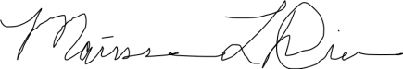
Marissa Diener, Ph.D.
Director, LEAP Learning Communities

3. High Impact Practices (June 19-22, 2018), AAC&U Summer Institute Proposal
Institutional Context and Current Goals Around Student Success:
`The University of Utah is a world-class research and teaching institution. The President has 4 strategic goals: promote student success, generate knowledge, engage communities, and ensure the long-term vitality of the University of Utah. The University enrolled 24,635 undergraduate students Fall 2017, 73% of whom were full-time students. First time entering freshman students were 4,119, 50% of whom were female, 94% of whom were full-time, and 67% of whom were resident. The Students First Initiative was launched as part of the Student Success goal. The Students First Initiative is comprised of 3 components: provide access and opportunity, increase odds for completion, and create an environment for student growth. This initiative has resulted in a steady increase in six-year graduation rates. From 2012-2017, our 6-year graduation rate improved from 58.9% to 67.4% for first-time, full-time freshman. Our goal is to continue the upward trajectory toward a 75% 6-year graduation rate. We also want to ensure access for all students and serve a more diverse student body. In 2017, mirroring the demographics of Salt Lake County, nearly one-third of our incoming, first-time freshman were domestic students of color. In addition, we are recruiting students beyond historic gender imbalances, such as recruiting more women to STEM fields and men to nursing programs.

The University of Utah has employed an institution-wide approach to promote student success and implement high-impact practices. The University of Utah pledges to provide students with the support necessary to be successful. The components of the Utah pledge include learning communities, mentors and advising, a plan to finish, and deeply engaged learning experiences. These programs occur across the University. Many programs are housed in Undergraduate Studies (UGS) – including many of the learning communities, Student Success Advocates (SSAs), the Office of Undergraduate Research, Capstone Initiatives, and the MUSE (“My Utah Signature Experience”) project. Since 2012, Undergraduate Studies has experienced significant growth and expansion of its work in supporting student success. We have added new teams to focus on specific issues students face: the Student Success and Empowerment Initiative, the Capstone Program, the Office of Inclusive Excellence, the Office of Engagement, the Learning Framework, and Uonline. Undergraduate Studies has strong partnerships with the Offices of Enrollment Management, Student Affairs, and the Academic Colleges. Undergraduate Studies organizes its work around three big goals that inspire retention and completion, and support student success.
- Every entering student in a learning community or living and learning community.
- Every student has at least one deeply engaged learning experience.
- Every student has a Plan to Finish and is supported by student success advocates, mentors, and advisors.
These three goals are embedded in the “Utah Pledge” which forms the central organizational principles of the Student Success website.
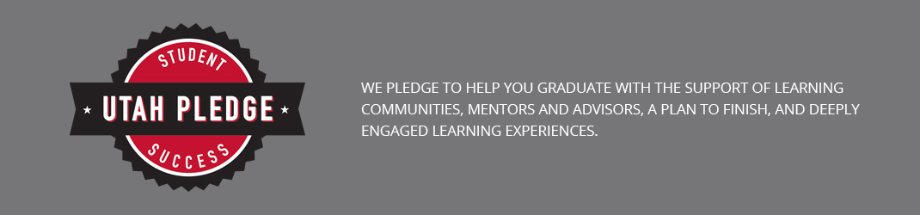
We provide deeply engaged learning experiences to students early at the beginning of their University experience. Students have a number of learning communities to choose from to best meet their needs, such as LEAP, BlockU, Honors, Diversity Scholars, Humanities Scholars, and Business Scholars. LEAP learning communities are the long-standing model of learning communities at the University of Utah. LEAP learning communities provide students with small classes taught by exceptional faculty in courses that meet general education requirements while also connecting students to their passions and interests. LEAP students take a first-year course together in a small cohort with the same faculty, a peer advisor, and an embedded librarian. LEAP learning communities have a record of positively increasing the likelihood of retention and degree completion, especially for students who enter the University less prepared. Entering first-time freshman are more likely to persist from Fall to Fall when they enroll in LEAP learning communities compared to non-LEAP students. Given these successes, we have established a goal that every entering student will enroll in a cohort learning community, such as LEAP, Honors, BlockU, Business Scholars, Humanities Scholars, or Diversity Scholars.
LEAP learning communities help students connect with their passions and majors. In Fall 2017, there were 26 sections of LEAP (serving 874 students) meeting general education requirements which connected with various Colleges in the University, including Engineering, Humanities, Social and Behavioral Sciences, Science, Health, and Fine Arts.
Although the LEAP program per se has not participated in an AAC&U Summer Institute previously, our colleagues in Undergraduate Studies have participated previously. We learn best practices, share resources, and meet across programs within Undergraduate Studies regularly. Thus, through our partnerships and connections, as well as through the large numbers of students LEAP serves, we will be able to expand the influence of the Summer Institute across the university.
Goals and Rationale for Summer Institute Participation:
In 2015, a committee was established to develop a systematic approach to assessing the learning that occurs in the context of learning communities, and to examine qualitative and quantitative tools to assess these communities. Three integrative learning outcomes (in addition to the general education outcomes such as critical thinking, information literacy and teamwork) emerged for our learning communities. These outcomes center on building connections and community:
- Intellectual Connections – students’ capacity for making connections among disciplines, experiences, and perspectives
- Reflection/Self-Assessment Connections – students develop the ability to self-assess (for example, through reflection, introspection, self-authorship)
- Community Connections – students feel a sense of belonging to campus and community
These learning outcomes are relatively new goals, and we would like to focus on developing high impact pedagogy that meet these goals in our LEAP classes and which connect systematically to other high impact practices. We have discussed pedagogical techniques, such as problem-based learning (PBL), which will help students develop these connections. Our initial pilot data based on a survey of N = 355 LEAP students in Fall 2017 indicate that Learning Outcome #3 – Community Connections – presents the largest challenge for the LEAP program. Our goals for the Institute center on addressing these learning outcomes.
More specifically, we plan to:
- Create a common strategy, activity or project for all LEAP sections
- Incorporate a systematic approach in LEAP to connecting students to Undergraduate Studies’ other High Impact Practices, such as Student Success Advocates (SSAs), MUSE, and the Bennion Center (described below). The goal is to support the Learning Outcomes, especially the Community Connections learning outcome.
- Connect underserved students with on-campus community resources. For example, we can build greater bridges between LEAP and ACCESS, a College of Science program for women in science and math, to support female students.

Our focus will be on equitable learning outcomes across student populations. LEAP will strive to create access and equitable pathways for all students, but especially for underserved or disadvantaged students to the variety of high impact practices on campus for even greater retention, completion and success rates.

Team Composition:
LEAP faculty focus on building connections between concepts central to the issues addressed in various colleges, such as the ethics of engineering for students in the College of Engineering, and bioethics for students in the College of Health.
There was some movement in team membership between proposal and attendance at the Institute. The attendees were:
Marissa Diener is Associate Professor of Family & Consumer Studies and Director, LEAP program.
Jennifer Brown is Associate Professor, Lecturer of Fine Arts, Arts, and Social and Behavioral Sciences LEAP.
Jennifer Seagrave is Assistant Professor, Lecturer of Engineering LEAP.
Margaret Harper is Associate Professor, Lecturer of Engineering and Science LEAP and faculty advisor to Phi Eta Kapa.
Ann Engar is Professor, Lecturer and teaches the pre-law LEAP sequence.
As the longest standing, largest learning community at the University of Utah, and a model program, LEAP needs to lead the way in addressing the Learning Community outcomes, which have been adopted by the major learning communities at the University of Utah (i.e., HONORS, LEAP, BlockU, Diversity Scholars, and Humanities Scholars).

Membership List for the LEAP Policy Board
First Name | Last Name | Title
Amy | Bergerson | Director, Student Success Advocates
Martha | Bradley-Evans | Senior Associate Vice President, Academic Affairs and Dean of Undergraduate Studies
Ann | Darling | Senior Associate Dean of Undergraduate Studies
Bobbi | Davis | Director, Advising College of Social and Behavorial Science
Marissa | Diener | Director, LEAP Program
Taunya | Dressler | Assistant Dean, College of Humanites
Ann | Engar | Professor/Lecturer - LEAP
Bob | Flores | Professor of Law
Jordan | Gerton | Associate Professsor, Physics and Astronomy
Beth | Howard | Associate Dean, Academic Advising Center
Dale | Larsen | Associate Librarian, MLIB
Connie | Madden | Associate Professor (clinical) College of Nursing
Steve | Maisch | Assistant Professor/ Lecturer - Assistant Director LEAP
Julie | Metos | Assistant Professor - College of Health
Ajay | Nahanta | Associate Dean - Electrical and Computer Engineering
Carolan | Ownby | Professor/Lecturer - Associate Director LEAP
Aaron | Reynolds | Director, Student Services, Honors College
Brent | Schneider | Assoicate Dean, College of Fine Arts
Nomani | Satuala | Interim Director, New Student and Family Programs
Seetha | Veeraghanta | Associate Professor/Lecturer - LEAP, Assistant Director
Tino | Nyawelo | Assistant Profesor/Lecturer, Physic and Astronomy
LEAP Policy Board Meeting
10/31/17

- Introductions
- Role of Policy Board
Ambassadors
Sounding Board

- LEAP mission and goals
Student Success
Partnerships with Colleges and Other Units on Campus

- Recent Accomplishments

Enrollment – 874 students; 774 first year, 23 transfer students, and 77 multi-year in 26 sections
10 sections Engineering LEAP
4 sections of Health Professions LEAP
2 sections SBS
2 sections Exploration LEAP
1 Service LEAP
1 Science
1 Humanities
1 Fine Arts
1 Pre-Law
1 Health Sciences (application only)
1 Transfer

Refuges Program Partnership

- Upcoming Year
LEAP faculty committees (assessment, pedagogy, faculty development)
Library Partnership Assessment
Access Program Partnership
On Line Section of Fine Arts LEAP
Strengthening partnerships and forging new partnerships
(Spring Semester – Michael White Review)

- Feedback and Suggestions
Future directions, evolution of the program
Skills Students Need
Connecting Students with Colleges and Majors
Exploring Students

LEAP Policy Board Meeting
3/9/18

- Introductions
- LEAP Updates
- Mike White – Rank Review

